**LOSSLESS DATA COMPRESSION ALGORITHMS AND THEIR COMPARISON**

**Project Report**

*submitted in partial fulfillment of*

*the requirements for the award of the degree of*

**BACHELOR OF TECHNOLOGY**

**in**

**COMPUTER SCIENCE Specialization in**

**Cloud Computing and Virtualization Technology**

**By :**

|  |  |
| --- | --- |
| **NAME** | **ENROLLMENT NO.** |
| ASHI AGARWAL | R110216043 |
| DEEPANSHU GOYAL | R110216057 |
| ARPIT BHARDWAJ | R110216039 |
| ASHISH BANSAL | R110216044 |

***Under the guidance of***

MR. G.L. PRAKASH

Assistant Professor, Department of Virtualization



**Department of Virtualization**

**School of Computer Science**

**UNIVERSITY OF PETROLEUM AND ENERGY STUDIES Bidholi, Via Prem Nagar, Dehradun, Uttarakhand**

**2018-19**



**CANDIDATES DECLARATION**

I/We hereby certify that the project work entitled  **Lossless Data Compression Algorithms and their Comparison** is in partial fulfilment of the requirements for the award of the Degree of Bachelor of Technology in Computer Science And Engineering with Specialization in Cloud Computing and Virtualization Technology and submitted to the Department of Virtualization at School of Computer Science, University of Petroleum And Energy Studies, Dehradun, is an authentic record of my/our work carried out during a period from **September, 2018** to **December, 2018** under the supervision of **Mr. G.L. PRAKASH, Assistant Professor, Department of Virtualization**

The matter presented in this project has not been submitted by me/ us for the award of any other degree of this or any other University.

Ashi Agarwal

Roll No R110216043

Deepanshu Goyal

Roll No R110216057

Arpit Bhardwaj

Roll No R110216039

Ashish Bansal

Roll No R110216044

This is to certify that the above statement made by the candidate is correct to the best of my/our knowledge.

Dr. Amit Agarwal

Head Department of Virtualization

School of Computer Science.

University of Petroleum And Energy Studies Dehradun - 248001 (Uttarakhand)

Mr. G.L. Prakash

Project Guide

Asst. Professor(SG)

School of Computer Science,

UPES, Dehradun

**ACKNOWLEDGEMENT**

We wish to express our deep gratitude to our guide **Mr. G.L. Prakash**, for all advice, encouragement and constant support he has given us throughout our project work. This work would not have been possible without his support and valuable suggestions.

We sincerely thank to our Head of the Department, **Dr. Amit Agrawal**, for his great support in

doing our project  **Lossless Data Compression Algorithms and their Comparison** at SoCS.

We are also grateful to **Dr. Manish Prateek Professor and Director SoCS** and **Dr. Kamal Bansal Dean CoES,** UPES for giving us the necessary facilities to carry out our project work successfully.

We would like to thank all our **friends** for their help and constructive criticism during our project work. Finally we have no words to express our sincere gratitude to our **parents** who have shown us this world and for every support they have given us.

**Name Ashi Agarwal Deepanshu Goyal Arpit Bhardwaj Ashish Bansal**

**Roll No. R110216043 R110216057 R110216039 R110216044**

**ABSTRACT**

In today’s world, With the advent of the Internet and mobile devices with limited resources and with the growing requirements of information storage and data transfer, Cloud Computing has become an important aspect, but cloud computing also require physical infrastructure, somewhere down the lane. This exponential sub purge of data leads to high demand for data processing that leads to a high computational requirement which is usually not available at the user's end. Compression reduces the redundancy in data representation thus increasing effective data density. [1] Data Compression is a technique which is used to decrease the size of data. This is very useful when some huge files have to be transferred over networks or being stored on a data storage device and the size is more than the capacity of the data storage or would consume so much bandwidth for transmission in a network. With the limited physical infrastructure for storage, data compression has gained even more importance these days. There are number of data compression algorithms, which are dedicated to compressing different data formats. Even for a single data type, there are number of different compression algorithms, which use different approaches. In this project, we will examine lossless data compression algorithms like Huffman encoding algorithm, Lempel-Ziv-Welch algorithm, and Shannon-Fano algorithm and comparing their performance. [2]

**Keywords**: Cloud Computing, Data Compression, Huffman encoding algorithm, Lempel-Ziv-Welch algorithm, Shannon-Fano algorithm.

**TABLE OF CONTENTS**

**Contents**

**1 Introduction**

**2 Literature Review**

**3 Problem Statement**

**4 Objective**

**5 Methodology**

**6 Algorithm**

**7 System Requirement**

**8 Implementation**

**9 Schedule(Pert Chart)**

**10 Limitation and Future Scope**

**11 Conclusion**

**12 References**

**A. APPENDIX I PROJECT CODE**

**LIST OF TABLES**

**1.0 Comparison between Lossy and Lossless Data Compression Technique.**

**1.1 Uniformly Distributed Data**

**1.2 Non-Uniform Evenly Distributed Data**

**1.3 Non-Uniformly Distributed Data**

**1.4 Time-Complexity**

**1.5 Compression ratio**

**1.6 Compression-factor**

**1.7 Encoded File size**

**1.8 Saving Percentage**

**1. INTRODUCTION**

Compression is the art of representing the information in a compact form rather than its original or in uncompressed form [3]. In other words, using the data compression, the size of a particular file can be reduced. This is very useful when processing, storing or transferring a huge file, which needs lots of resources. If the algorithms used to encrypt works properly, there should be a significant difference between the original file and

the compressed file. When data compression is used in a data transmission application, speed is the primary goal. Speed of transmission depends upon the number of bits sent, the time required for the encoder to generate the coded message and the time required for the decoder to recover the original message. In a data storage application, the degree of compression is the primary concern. There are two types of data compressions ie. Lossless data compression and Lossy data compression.

Table 1.0 :Comparison between Lossy and Lossless Data Compression Technique.

|  |  |
| --- | --- |
| Lossless data compression | Lossy data compression |
| In Lossless data compression algorithms, the original data can be recovered from compressed data after applying decompression algorithm | In Lossy compression algorithms it permanently reduces the original data by eliminating certain information, especially redundant information, after decompressing the file only the part of original data is recovered. |
| Lossless compression is generally used for text data or spreadsheet files, where even a very small amount of data loss can be detected by users. | Lossy compression is generally used for video and sound, where a certain amount of information loss will not be detected by most users. |
| No loss in information so compression rate is small. | In return for accepting this distortion in reconstructed data we obtain high compression rate. |
| Less data can be accommodated in channel. | More data can be accommodated in channel. |
| *E*.*g*(*i*)*F**a**x* *M**a**c**h**i**n**e*,(*i**i*)*R**a**d**i**o**l**o**g**i**c**a**l* *I**m**a**g**i**n**g* | *E*.*g*.(*i*)*T**e**l**e**p**h**o**n**e* *S**y**s**t**e**m*,(*i**i*)*V**i**d**e**o* *C**D* |

Various lossless data compression algorithms have been proposed and used. Some of the main techniques in use are the Huffman Coding, Run Length Encoding, Arithmetic Encoding and Dictionary Based Encoding [4]. We will examine the performance of the Huffman Encoding Algorithm, Shannon Fano Algorithm, and Lempel Zev Welch Algorithm. In particular, performance of these algorithms in compressing text data will be evaluated and compared.

**Shannon-Fano Algorithm:**

In Shannon–Fano Algorithm, the symbols are arranged in order from most probable to least probable, and then divided into two sets whose total probabilities are as close as possible to being equal. All symbols then have the first digits of their codes assigned; symbols in the first set receive "0" and symbols in the second set receive "1". As long as any sets with more than one member remain, the same process is repeated on those sets, to determine successive digits of their codes. When a set has been reduced to one symbol, of course, this means the symbol's code is complete and will not form the prefix of any other symbol's code. The algorithm works, and it produces fairly efficient variable-length encodings; when the two smaller sets produced by a partitioning are in fact of equal probability, the one bit of information used to distinguish them is used most efficiently. Unfortunately, Shannon–Fano does not always produce optimal prefix codes. [5]

**Huffman Encoding:**

The Huffman encoding works on variable length encoding rather than fixed length encoding. frequency of every character is calculated, and the lengths of the assigned codes are based on the frequencies of corresponding characters. The most frequent character gets the smallest code and the least frequent character gets the largest code. The variable-length codes assigned to input characters are Prefix Codes, means the codes (bit sequences) are assigned in such a way that the code assigned to one character is not prefix of code assigned to any other character. This is how Huffman Coding makes sure that there is no ambiguity when decoding the generated bit stream for this task a binary tree is created using the symbols as leaves according to their probabilities and paths of those are taken as the code words.

**The Lempel-Ziv Welch Algorithm:**

It is a dictionary-based compression algorithm As in Dictionary the set of all possible word of a language is stored similarly in LZW algorithm a dictionary is used to store or index the previously used string patterns In the compression process those index value is used instead of repeating. The dictionary is created dynamically in the compression process and no need to transfer it with the encoded message for decompressing. In the decompression process, the same dictionary is created dynamically. Therefore, this algorithm is an adaptive compression algorithm.

Performance of compression algorithm [6] is based on space efficiency and the time complexity.The compression behaviour of algorithm is dependent on redundancy of symbol in source file therefore it is difficult to measure the performance of compression algorithm. There are some following measurements used to evaluate the performances of compression algorithms.

Compression Ratio –Compression Ratio is the ratio between the size of the compressed file and the size of the source file

Compression ratio= (size of compressed file)/ (size of source file)

Compression Factor-Compression factor is inverse of Compression ratio.It tells how much times our file has been compressed

Compression Factor= (size of source file)/ (size of compressed file)

Saving Percentage-It tells the shrinkage of the source file in percentage

Saving Percentage= (size before compression-size after compression)/ (size before compression) %

Time complexity –The time complexity is measured by the number of clocks used to encode the source code. The algorithm that uses less clock cycle to encode is considered more efficient.

In this project we will be comparing all the three algorithms on the basis of these factors mentioned above.

**2. LITERATURE REVIEW**

Data Compression is the way that you can use the space on cloud i.e. Server in an optimal way. In this project we will Lossless Data Compression algorithms which can reconstruct the original message exactly from the compressed message Here is the conclusion of some of the reference paper that we review to make our project better and to know more technologies that we can use in our system.

In the paper [6] by S.R. KODITUWAKKU, Department of Statistics & Computer Science, University of Peradeniya, Sri Lanka, U. S. AMARASINGHE, Postgraduate Institute of Science, University of Peradeniya, Sri Lanka; Among the available lossless compression algorithms they considered the Run Length Encoding Algorithm, Huffman Encoding, The Shannon Fano Algorithm, Arithmetic Encoding, The Lempel Ziv Welch Algorithm for study. They carried out an experimental comparison of a number of different lossless compression algorithms for text data. On the basis of compression times, decompression times and saving percentages of all the algorithms, they found that the Shannon Fano algorithm can be considered as the most efficient algorithm among the selected ones. The values which they calculated are in the acceptable range and it also shows better results for the larger files.

In the paper [7] by Laxmi Shaw, Student Member, IEEE, Daleef Rahman, and Aurobinda Routray, Senior Member, IEEE; The authors have examined the different lossless compression methods for single and multichannel EEG signals, and their performance with respect to their relative Compression ratios has been analysed. They evaluate their proposed algorithms, analysis of which showed that a very high CR (Compression Ratio) in different publicly available database. They also analysed that among the existing methods for the single-channel EEG compression scheme, the linear prediction followed by the context-based error modelling showed the best results. The increase in CR by applying the context-based error modelling is high for the first-order predictor, whereas the increase is small for higher-order predictors. The MVAR model and the bivariate autoregression model were examined for the multichannel EEG compression. The results show that these proposed methods in combination outperform the existing MVAR and the bivariate autoregressive model.

**3. PROBLEM STATEMENT**

Storage on the cloud is a limited resource. Even though more storage space can be purchased, it seems better to utilize the given space to the fullest. The solution to this problem is data compression. Compress data to save space and then store it on the cloud, also in doing so, we save the data transmission cost over the network and make our cloud storage even more efficient.

**4. OBJECTIVES**

**5. METHODOLOGY**

· Research .

· Analysis.

· Selection of Text file to be Compressed.

· Compress using all three Data Compression algorithms:

1. Huffman Encoding Algorithm.
2. Shannon-fano Algorithm.
3. Lempel-ziv 77 Algorithm.

·Calculate all comparison factors for all three algorithms.

1. Compression Ratio.
2. Compression Factor.
3. Time Complexity.
4. Encoded File Size.
5. Saving Percentage.

· Comparison between algorithms on the basis of above factors.

· Showing Results in tabular form

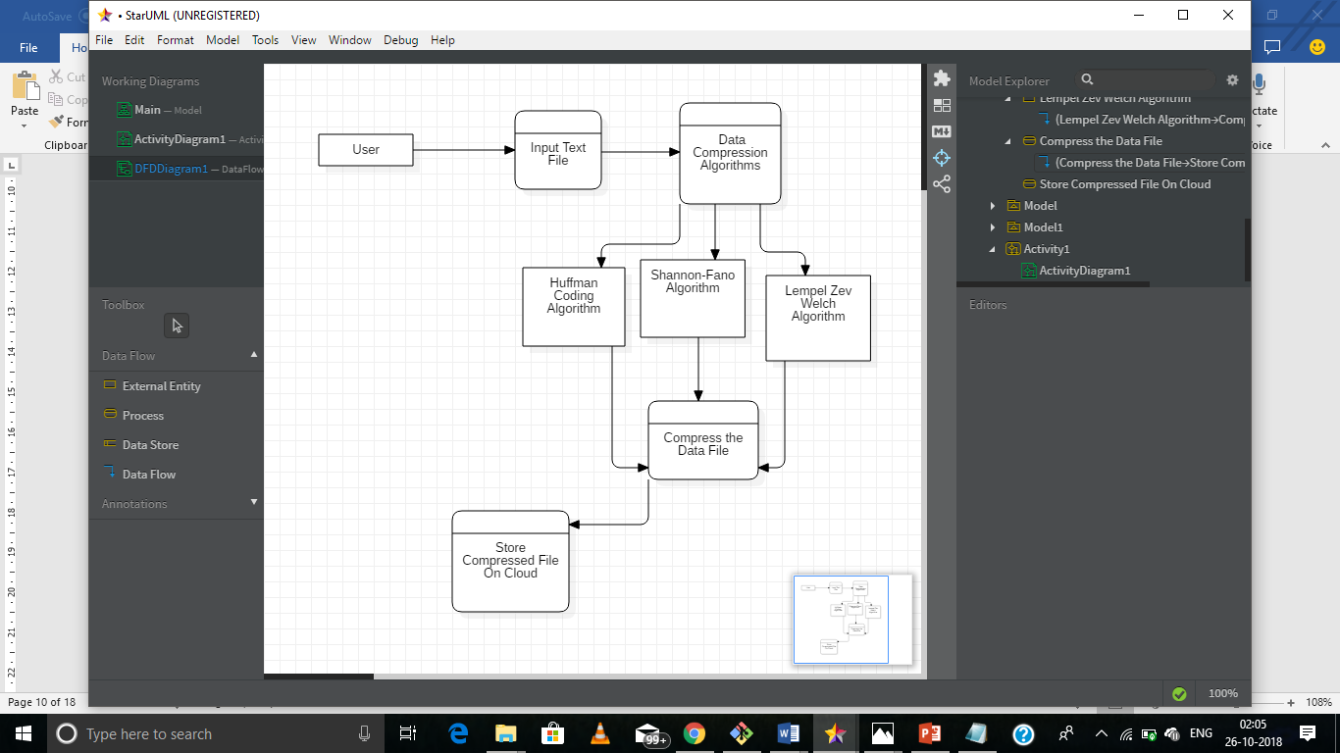

**6. ALGORITHM**

Data Compression will be done by these of three Algorithms defined below:

**Huffman Coding:**

Huffman coding is lossless data compression algorithm that comes under Greedy Algorithm. The basic idea behind Algorithm is to assign variable length code to each character based on their frequency

There are two part of Huffman encoding

a) Creating a Huffman tree

b) Traverse the tree and assign code to each character

1. Creating a Huffman tree

Step1- Create a leaf node for each unique character and build a min heap for each character

Step2- Extract two node (Whose frequency is minimal) from min heap say node1 and node2

Step3- Create a new internal node whose frequency is equal to sum of two extracted node assign node 1 as a left child and node 2 as aright child

Step4-Repeat step2 and step3 until the min heap does not contain only one node. The remaining node is root node and the tree has been completed

1. Traverse the tree and assign code to each character

Step1- Traverse the tree formed starting from the root. Maintain an auxiliary array.

Step2- While moving to the left child, write 0 to the array.

Step3- While moving to the right child, write 1 to the array.

Step4- Print the array when a leaf node is encountered.

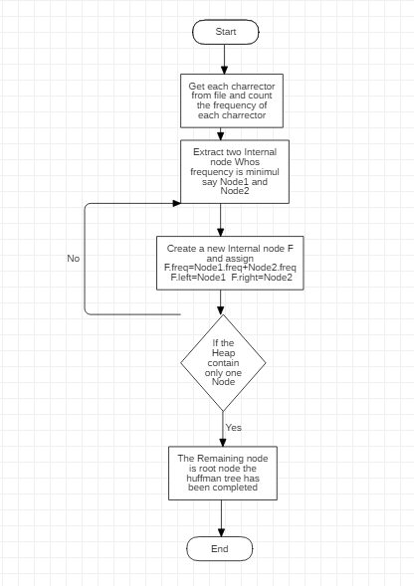

**Shannon-Fano :**

Shannon-fano algorithm is a lossless data compression algorithm named after Claude Shannon and Robert Fano, in this technique we construct a code for each character which depends upon the frequency of that character and then encode the file accordingly.

There are two part of Huffman encoding

a) Creating a Shannon-Fano tree

b) Traverse the tree and assign code to each character.

Creating a Shannon-Fano tree

Step 1: Calculate frequency of each unique character.

Step 2: Calculate probability of each unique character in the file.

Step 3: Arrange the probability in decreasing order.

Step 4: Divide the Array in two parts in such a way that sum of probability of one part almost equal to sum of probability of other part.

Step 5: Keep diving the array till only two probability are left in sub-parts.

Step 6: Assign 0 to all left sub-edges and 1 to all right sub-edges .

Traverse the tree and assign code to each character.

Step 1:Calculate the code for each character by taking 0 and 1 values of the edges required to reach the leaf node of that character.

Step 2:Traverse the file and write corresponding code of each character in a binary file.

Step 3:Save Binary file.

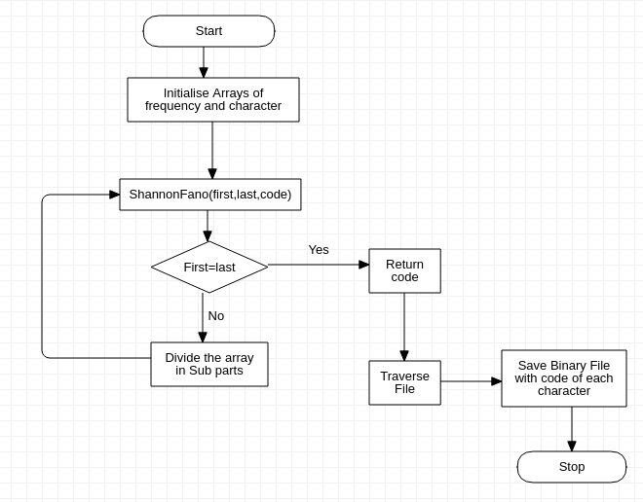

**Lempel-Ziv-Welch :**

while (lookAheadBuffer not empty) {

get a reference (position, length) to longest match;

if (length > 0) {

output (position, length, next symbol);

shift the window length+1 positions along;

} else {

output (0, 0, first symbol in the lookahead buffer);

shift the window 1 character along;

}}

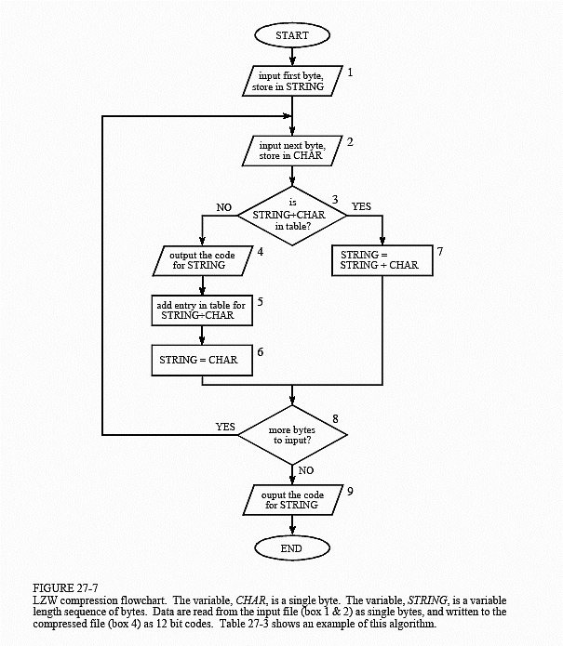

**7. SYSTEM REQUIREMENTS (Software/Hardware)**

* HARDWARE:

1. 64 bits processor architecture supported by windows.
2. Minimum RAM requirement for proper functioning is 8 GB.
3. Required input as well as output devices.

* SOFTWARE:

1. C Compiler (GCC).
2. Git

**8. IMPLEMENTATION**

**Pseudo code for Huffman encoding:**

Let C is set of n character such that every character c belongs to C every character has a attribute is frequency. And Q is a min priority queue based on frequency of characters

Huffman(C)

{

// input : C set of n character with their frequency

// Output : Huffman tree

n=|C|

Q=C

for i=1 to n-1 do

Allocate a new internal node z

z.left=x=Extract-Min(Q) //Extracting two internal nodes with lowest frequency

z.right=y=Extract-Min(Q) //And assigning that sum to new internal node

z.freq=x.freq+y.freq

Insert(Q,z)

return Extract-Min(Q) //return the root of the tree

}

Time complexity of creating Huffman tree

= (time complexity to Extract min node)*2(n-1) // where n is number of character

=O(logn)*2n

=O(nlogn)

**Pseudo code for Shannon-Fano encoding:**

Take two Arrays Probability[] which consist probability of each character ,and Character[] that consist the consist of all the character in the same order of there probability.

Probability[]={0.30,0.25,0.15,0.12,0.10,0.08}

Character[]={'a','c','s','b','m','n'}

Shannonfano( initial, final, code)

{

If initial=final:

print code and return.

Else

Assign first=initial,last=final

Assign sumFront=probability[first], sumLast=probability[last]

while first!=last:

If sumFront>sumLast:

Decrement last by 1

endif

Assign sumLast=sumLast+probability[last]

Else

Increment first by 1

Assign sumFront=sumFront+probability[first]

endElse

Assign code=code*10

Shannonfano(initial,first,code+0)

Shannonfano(first+1,final,code+1)

}

Time-Complexity of Shannon-Fano algorithm

T(n) = T(n/2) + T(n/2) + n

T(n) = 2T(n/2) + n

=O(nLog2(n))

**Pseudo code for Lempel-ziv 77 algorithm:**

{

Initialize table with single character strings

P = first input character

WHILE not end of input stream

C = next input character

IF P + C is in the string table

P = P + C

ELSE

output the code for P

add P + C to the string table

P = C

END WHILE

output code for P

}

**9. SCHEDULE (PERT CHART)**

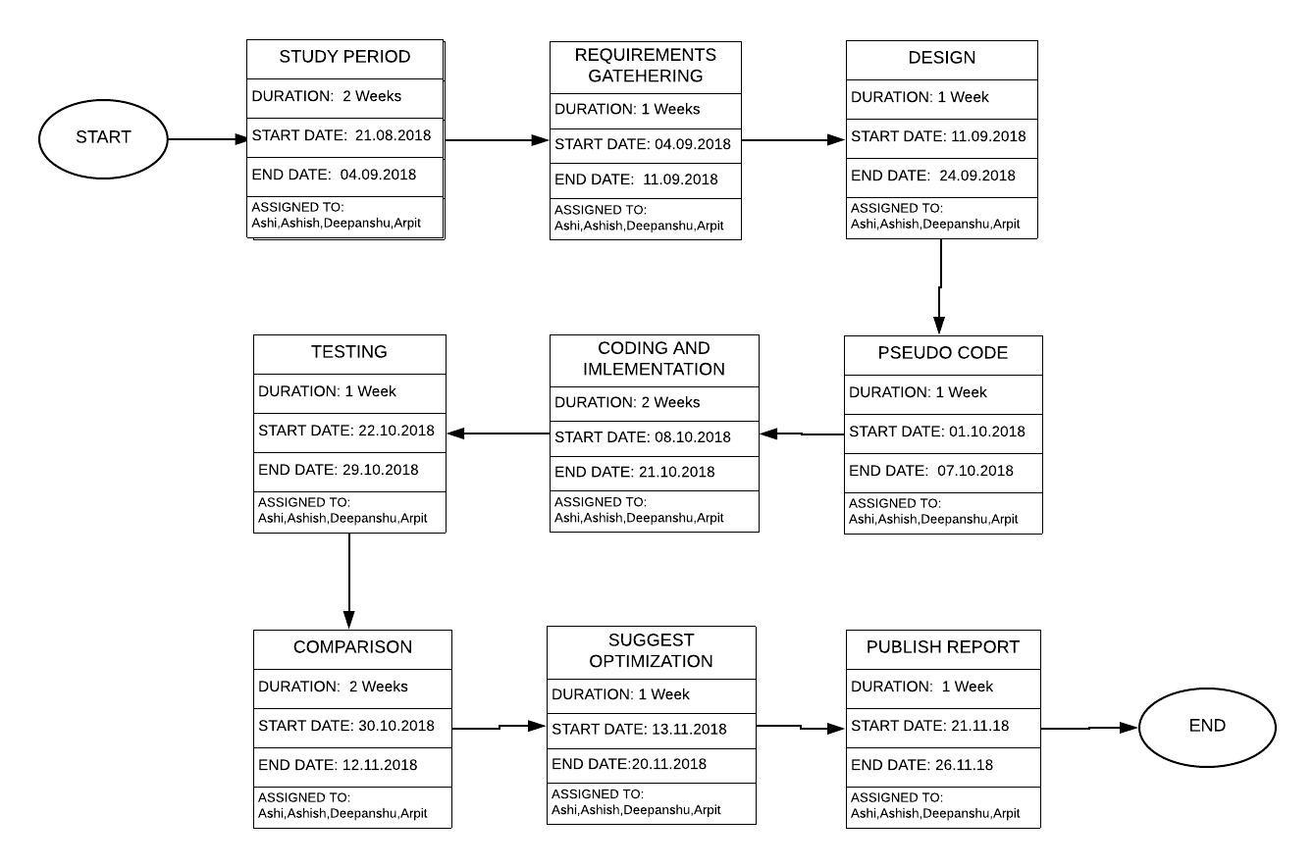

**10. LIMITATIONS AND FUTURE SCOPE**

1. These three algorithms are conventional algorithm and enough modification and optimization has already been done so further optimization can't be suggested.
2. Compression of different Characters other than 128 and symbol which are not defined in the dictionary,can't be achieved.
3. Compression of databases which contains less redundant data is not computationally profitable in lempel ziv algorithm.

**11.** **CONCLUSION**

The end of this project brings us to the follwing Conclusions :  
1) Since the exponential growth in data and limited storage space,data compression plays a major role in today’s world.  
2) Any algorithm discussed above can't be termed as best or worst as they all depend on the type of data which has been compressed by them.  
3) Each algorithm has its own advantages and disadvantages and has it's own applications.  
4) The three algorithm discussed and implemented by us are conventional compression algorithms and their different subsidiaries with different optimizations have already been developed so there lies a limited scope in their optimization.

**Results:**

**Input file size : 2272 bytes**

**File name : input.txt**

**Table 1.1-Uniform distribution**

|  |  |  |  |
| --- | --- | --- | --- |
| **Comparison Factors** | **Huffman encoding algorithm** | **Shannon fano algorithm** | **Lempel-ziv 77 algorithm** |
| Compression ratio | 0.25080 | 0.481954 | 0.577465 |
| Compression Factor | 3.985965 | 2.074886 | 1.731707 |
| Encoded File size | 570 bytes | 1095 bytes | 1312 bytes |
| Time complexity | 0.000667 | 0.001052 | 0.001119 |
| Length of code | 271 | 116 | 170 |
| Saving percentage | 74.911972 | 51.804577 | 42.253521 |

**Conclusion for table 1.1**

For a uniformly distributed data in a file the compression ratio for the huffman encoding algorithm is least, that is for a uniformly distributed file Huffman encoding algorithm is working best and saving percentage is also high with minimum time complexity also reduces the file size by 75 % (Approx) While Shannonfano reduces it to 52% (Approx) and LZ77 reduces it to 42% (Approx).

**Input file size : 1384 bytes**

**File name : input3.txt**

**Table 1.2-Non Uniform(even) distribution**

|  |  |  |  |
| --- | --- | --- | --- |
| **Comparison Factors** | **Huffman encoding algorithm** | **Shannon fano algorithm** | **Lempel-ziv 77 algorithm** |
| Compression ratio | 0.251445 | 0.357659 | 0.531792 |
| Compression Factor | 3.977011 | 2.795960 | 1.880435 |
| Encoded File size | 348 bytes | 495 bytes | 736 bytes |
| Time complexity | 0.000526 | 0.000605 | 0.000904 |
| Length of code | 271 | 116 | 170 |
| Saving percentage | 74.855492 | 64.234100 | 46.820812 |

**Conclusion for table 1.2**

For a Non-uniform evenly distributed data in a file the compression ratio for the huffman encoding algorithm is least, that is for a Non-uniform evenly distributed file Huffman encoding algorithm is working best and saving percentage is also high with minimum time complexity also reduces the file size by 75% (Approx) While Shannonfano reduces it to 64% (Approx) and LZ77 reduces it to 46% (Approx).

**Input file size : 4840 bytes**

**File name : input1.txt**

**Table 1.3-Non Uniform distribution**

|  |  |  |  |
| --- | --- | --- | --- |
| **Comparison Factors** | **Huffman encoding algorithm** | **Shannon fano algorithm** | **Lempel-ziv 77 algorithm** |
| Compression ratio | 0.249174 | 0.429339 | 0.119008 |
| Compression Factor | 4.013267 | 2.329163 | 8.402778 |
| Encoded File size | 1206 bytes | 2078 bytes | 576 bytes |
| Time complexity | 0.001453 | 0.001420 | 0.005355 |
| Length of code | 271 | 116 | 170 |
| Saving percentage | 75.082642 | 57.066113 | 88.099174 |

**Conclusion for table 1.3**

For a Non-uniformly distributed data in a file the compression ratio for the LZ77 algorithm is least, that is for a Non-uniformly distributed file LZ77 algorithm is working best and saving percentage is also high also reduces the file size by 88% (Approx) ,While Shannonfano reduces it to 57% (Approx) and Huffman encoding algorithm reduces it to 75% (Approx).

**Table 1.4 -Time complexity**

|  |  |  |  |  |
| --- | --- | --- | --- | --- |
| **File name** | **File size**  **(in bytes)** | **Huffman encoding algorithm** | **Shannon-fano algorithm** | **Lempel-ziv 77 algorithm** |
| input8.txt | 448 | 0.000608 | 0.000824 | 0.001272 |
| input10.txt | 1384 | 0.000636 | 0.001064 | 0.001644 |
| input1.txt | 1936 | 0.001065 | 0.001093 | 0.002505 |
| input2.txt | 5264 | 0.000292 | 0.000370 | 0.001395 |
| input4.txt | 6856 | 0.002414 | 0.002788 | 0.012018 |
| input6.txt | 10456 | 0.003693 | 0.003008 | 0.018217 |
| input3.txt | 11776 | 0.004316 | 0.003003 | 0.024441 |
| input5.txt | 19392 | 0.002497 | 0.001584 | 0.011361 |
| input7.txt | 29864 | 0.002680 | 0.006254 | 0.020151 |
| input9.txt | 68152 | 0.004373 | 0.002717 | 0.042222 |

**Conclusion for table 1.4**

* As we increase file size the Time complexity of Huffman Algorithm increases linearly.
* As we increase file size the Time complexity of Shannonfano Algorithm increases or decreases depending on type of data.
* As we increase file size the Time complexity of LZ77 Algorithm increases abruptly.

**Table 1.5 -Compression ratio**

|  |  |  |  |  |
| --- | --- | --- | --- | --- |
| **File name** | **File size**  **(in bytes)** | **Huffman encoding algorithm** | **Shannon fano algorithm** | **Lempel-Ziv 77 algorithm** |
| input8.txt | 448 | 0.254464 | 0.392857 | 1.589286 |
| input10.txt | 1384 | 0.251445 | 0.393064 | 1.208092 |
| input1.txt | 1936 | 0.251033 | 0.421488 | 0.252066 |
| input2.txt | 5264 | 0.242021 | 0.484992 | 0.278116 |
| input4.txt | 6856 | 0.248541 | 0.441219 | 0.072345 |
| input6.txt | 10456 | 0.249809 | 0.436400 | 0.005356 |
| input3.txt | 11776 | 0.247113 | 0.467221 | 0.151495 |
| input5.txt | 19392 | 0.250103 | 0.467512 | 0.030116 |
| input7.txt | 29864 | 0.249933 | 0.468624 | 0.013126 |
| input9.txt | 68152 | 0.249677 | 0.486031 | 0.000704 |

**Conclusion for table 1.5**

* As we increase file size the Compression ratio of Huffman encoding Algorithm remains almost Constant .Average Compression ratio of Huffman encoding algorithm is 0.249414.
* As we increase file size the Compression ratio of Shannonfano Algorithm remains almost Constant .Average Compression ratio of Shannonfano algorithm is 0.3991896
* As we increase file size the Compression ratio of LZ77 Algorithm decreases abruptly.

**Table 1.6-Compression factor**

|  |  |  |  |  |
| --- | --- | --- | --- | --- |
| **File name** | **File size**  **(in bytes)** | **Huffman encoding algorithm** | **Shannon fano algorithm** | **Lempel-Ziv 77 algorithm** |
| input8.txt | 448 | 3.929825 | 2.545455 | 0.629214 |
| input1.txt | 1936 | 3.983539 | 2.372549 | 3.967213 |
| input10.txt | 1384 | 3.977011 | 2.544118 | 0.827751 |
| input2.txt | 5264 | 4.131866 | 2.061888 | 3.595628 |
| input4.txt | 6856 | 4.023474 | 2.266446 | 13.822580 |
| input6.txt | 10456 | 4.003063 | 2.291475 | 186.714279 |
| input3.txt | 11776 | 4.046735 | 2.140313 | 6.600897 |
| input5.txt | 19392 | 3.998351 | 2.138981 | 33.205479 |
| input7.txt | 29864 | 4.001072 | 2.133905 | 76.183670 |
| input9.txt | 68152 | 4.005172 | 2.057481 | 1419.83374 |

**Conclusion for table 1.6**

* As we increase file size the Compression factor of Huffman encoding Algorithm remains almost Constant .Average Compression factor of Huffman encoding algorithm is 4.0100108.
* As we increase file size the Compression factor of Shannonfano Algorithm remains almost Constant .Average Compression factor of Shannonfano algorithm is 2.2552611
* As we increase file size the Compression factor of LZ77 Algorithm increases abruptly.

**Table 1.7-Encoded file size**

|  |  |  |  |  |
| --- | --- | --- | --- | --- |
| **File name** | **File size**  **(in bytes)** | **Huffman encoding algorithm** | **Shannon fano algorithm** | **Lempel-ziv 77 algorithm** |
| input8.txt | 448 | 114 | 176 | 712 |
| input10.txt | 1384 | 348 | 544 | 1672 |
| input1.txt | 1936 | 486 | 816 | 488 |
| input2.txt | 5264 | 1274 | 2553 | 1464 |
| input4.txt | 6856 | 1704 | 3025 | 496 |
| input6.txt | 10456 | 2612 | 4563 | 56 |
| input3.txt | 11776 | 2910 | 5502 | 1784 |
| input5.txt | 19392 | 4050 | 9066 | 584 |
| input7.txt | 29864 | 7464 | 13995 | 392 |
| input9.txt | 68152 | 17016 | 33124 | 48 |

**Conclusion for table 1.7**

* For Huffman encoding algorithm the file size is always reduced by almost 74%-75%.
* For Shannonfano algorithm the file size is always reduced by around 55%-60%.
* As We Mentioned that Lempel-ziv 77 algorithmis Dictionary based Algorithm, the reduction of file size is highly dependent on data, if a word repeats several times in our Data File it reduces our file Size to 95%-98**%** ,otherwise for a very small file it sometimes even increases the file size.

**Table 1.8-Saving percentage**

|  |  |  |  |  |
| --- | --- | --- | --- | --- |
| **File name** | **File size**  **(in bytes)** | **Huffman encoding algorithm** | **Shannon fano algorithm** | **Lempel-ziv 77 algorithm** |
| input8.txt | 448 | 74.553574 | 60.714287 | -58.928574 |
| input10.txt | 1384 | 74.855492 | 60.693638 | -20.89248 |
| input1.txt | 1936 | 74.896690 | 57.851238 | 74.793388 |
| input2.txt | 5264 | 75.797874 | 51.500763 | 72.188446 |
| input4.txt | 6856 | 75.145859 | 55.878059 | 92.765465 |
| input6.txt | 10456 | 75.019127 | 56.359982 | 99.464424 |
| input3.txt | 11776 | 75.288727 | 53.277855 | 84.850540 |
| input5.txt | 19392 | 74.989685 | 53.248764 | 96.988449 |
| input7.txt | 29864 | 75.006699 | 53.137558 | 98.687378 |
| input9.txt | 68152 | 75.032280 | 51.396877 | 99.929573 |

**Conclusion for table 1.8**

* For Huffman encoding algorithm the saving percentage is almost 74%-75%.
* For Shannonfano algorithm the saving percentage is almost 55%-60%.
* As We Mentioned that Lempel-ziv 77 algorithm is Dictionary based Algorithm, saving percentage is highly dependent on data, if a word repeats several times in our Data File saving percentage increases to 95%-98**%** ,but for a very small file size sometimes saving percentage may even go negative.

**12. REFERENCES**

1. Monika Soni , Dr Neeraj Shukla “Data Compression Techniques in Cloud Computing”
2. Mohammad Hosseini “A Survey of Data Compression Algorithms and their Applications”
3. Pu, I.M., 2006, Fundamental Data Compression, Elsevier, Britain.
4. Kesheng, W., J. Otoo and S. Arie, 2006. Optimizing bitmap indices with efficient compression, ACM Trans. Database Systems, 31: 1-38.
5. [https://www.google.com/url?sa=t&rct=j&q=&esrc=s&source=web&cd=15&ved=2ahUKEwjW8piM_q_dAhVHyrwKHXE2DHoQFjAOegQIABAC&url=http%3A%2F%2Fecehithaldia.in%2Fteaching_material%2FShanon-Fano1586521731.pdf&usg=AOvVaw0MHM4foSS-sDhzqyRAVfaE](http://ecehithaldia.in/teaching_material/Shanon-Fano1586521731.pdf)
6. S.R. Kodituwakku ,U. S. Amarasinghe “Comparision of Lossless data compression algorithms for text data”
7. Highly Efficient Compression Algorithms for Multichannel EEG,Laxmi Shaw , Student Member, IEEE , Daleef Rahman, and Aurobinda Routray, Senior Member, IEEE
8. A Survey of Data Compression Algorithms and their Applications ,Mohammad Hosseini
9. Network Systems Lab, School of Computing Science, Simon Fraser University, BC, Canada,Email: mohammad [hosseini@sfu.ca](mailto:hosseini@sfu.ca)

**A . APPENDIX I PROJECT CODE**

**Huffman.c**

#include <stdio.h>

#include <stdlib.h>

#include<time.h>

#define HEIGHT 100

int frequency[128]={0};

int temp[128];

int* ard[107];

int len;

typedef struct NODE Node;

struct NODE {

char data;

int freq;

Node *left, *right;

};

typedef struct {

int size;

int capacity;

Node** array;

}MinHeap;

Node* newNode(char data, int freq)

{

Node* temp= (Node*)malloc

(sizeof(Node));

temp->left = temp->right = NULL;

temp->data = data;

temp->freq = freq;

return temp;

}

void sort_huffman(int *frequency ,int *temp)

{

int a,i,j;

for (i = 0; i < 128; ++i) {

if(!(frequency[i]>0.0))

{

continue;

}

for (j = i + 1; j < 128; ++j)

{

if (frequency[i] < frequency[j]) {

a = frequency[i];

frequency[i] = frequency[j];

frequency[j] = a;

a=temp[i];

temp[i]=temp[j];

temp[j]=a;

} } } }

void file_read(char * filename)

{

FILE *fp;

int length=0;

int i;

fp = fopen( filename, "r" ) ;

if ( fp == NULL ){

printf( "Could not open file %s\n",filename ) ; }

int c;

while((c = fgetc(fp))!=EOF){

frequency[c]++;

length++;

}

for(i=0;i<128;i++)

{

temp[i]=i; }

sort_huffman(frequency,temp);

fclose(fp);

}

MinHeap* createMinHeap(int capacity)

{

MinHeap* minHeap = (MinHeap*)malloc(sizeof(MinHeap));

minHeap->size = 0;

minHeap->capacity = capacity;

minHeap->array

= (Node**)malloc(minHeap->

capacity * sizeof(Node*));

return minHeap;

}

void swapNode(Node** a,Node** b)

{

Node* t = *a;

*a = *b;

*b = t;

}

void minHeapify(MinHeap* minHeap, int idx)

{

int smallest = idx;

int left = 2 * idx + 1;

int right = 2 * idx + 2;

if (left < minHeap->size && minHeap->array[left]->

freq < minHeap->array[smallest]->freq)

smallest = left;

if (right < minHeap->size && minHeap->array[right]->

freq < minHeap->array[smallest]->freq)

smallest = right;

if (smallest != idx) {

swapNode(&minHeap->array[smallest],

&minHeap->array[idx]);

minHeapify(minHeap, smallest);

} }

int isSizeOne(MinHeap* minHeap)

{

return (minHeap->size == 1);

}

Node* extractMin(MinHeap* minHeap)

{

Node *temp = minHeap->array[0];

minHeap->array[0]= minHeap->array[minHeap->size - 1];

--minHeap->size;

minHeapify(minHeap, 0);

return temp;

}

void insertMinHeap(MinHeap* minHeap,Node* minHeapNode)

{

++minHeap->size;

int i = minHeap->size - 1;

while (i && minHeapNode->freq < minHeap->array[(i - 1) / 2]->freq) {

minHeap->array[i] = minHeap->array[(i - 1) / 2];

i = (i - 1) / 2;

}

minHeap->array[i] = minHeapNode;

}

void buildMinHeap(MinHeap* minHeap)

{

int n = minHeap->size - 1;

int i;

for (i = (n - 1) / 2; i >= 0; --i)

minHeapify(minHeap, i);

}

void printArr(int arr[], int n)

{

int i;

ard[len]=(int*)malloc(sizeof(int)*n);

for(i=0;i<n;i++)

ard[len][i]=arr[i];

len++;

}

int isLeaf(Node* root)

{

return !(root->left) && !(root->right);

}

MinHeap* createAndBuildMinHeap(char data[], int freq[], int size)

{

int i;

MinHeap* minHeap = createMinHeap(size);

for ( i = 0; i < size; ++i)

minHeap->array[i] = newNode(data[i], freq[i]);

minHeap->size = size;

buildMinHeap(minHeap);

return minHeap;

}

Node* buildHuffmanTree(char data[], int freq[], int size)

{

Node *left, *right, *top;

MinHeap* minHeap = createAndBuildMinHeap(data, freq, size);

while (!isSizeOne(minHeap)) {

left = extractMin(minHeap);

right = extractMin(minHeap);

top = newNode('$', left->freq + right->freq);

top->left = left;

top->right = right;

insertMinHeap(minHeap, top);

}

return extractMin(minHeap);

}

void printCodes(Node* root, int arr[], int top)

{

int i=0;

int j=0;

if (root->left) {

arr[top] = 0;

printCodes(root->left, arr, top + 1);

}

if (root->right) {

arr[top] = 1;

printCodes(root->right, arr, top + 1);

}

if (isLeaf(root)) {

printArr(arr, top);

}

}

void HuffmanCodes(char data[], int freq[], int size)

{

Node* root

= buildHuffmanTree(data, freq, size);

int arr[HEIGHT], top = 0;

printCodes(root, arr, top);

}

double executeHuffman(char * filename)

{

clock_t start,end;

double total_time;

start=clock();

len=0;

char c;

int i=0 ,j=0,k=0;

char arr[128];

int freq[128];

file_read(filename);

for(i=0;i<128;i++)

{

if(frequency[i]>0)

{

freq[k]=frequency[i];

arr[k]=(char)temp[i];

k++;

}

}

int size =k;

HuffmanCodes(arr, freq, size);

FILE *fp;

FILE *fptr;

if ((fptr = fopen("outputHuffman.txt","w")) == NULL){

printf("Error! opening file");

// Program exits if the file pointer returns NULL.

return 0;

}

fp = fopen( filename, "r" ) ;

if ( fp == NULL ){

printf( "Could not open file %s\n" ,filename) ;

return 1;

}

while((c = fgetc(fp))!=EOF){

for ( i = 0; i <size; ++i)

{

if(arr[i]==c){

for(j=0;j<sizeof(ard[i])/sizeof(int);j++)

{

fprintf(fptr,"%d",ard[i][j]);

}}}}

fclose(fp);

fclose(fptr);

end=clock();

total_time=(double)(end-start)/CLOCKS_PER_SEC;

return total_time;

}

**Shannonfano.c**

#include<string.h>

#include<stdio.h>

#include<time.h>

int codeword[128]={0};

void sort(int *frequency ,int *temp)

{

int a,i,j;

for (i = 0; i < 128; ++i) {

for (j = i + 1; j < 128; ++j)

{

if (frequency[i] < frequency[j])

{

a = frequency[i];

frequency[i] = frequency[j];

frequency[j] = a;

a=temp[i];

temp[i]=temp[j];

temp[j]=a;

}

}

}

}

void shannonfano(int initial,int final,int code,float *probability,int *character)

{

if(initial==final)

{

codeword[initial]=code;

return ;

}

int first=initial;

int last=final;

float sumFront=probability[first];

float sumLast=probability[last];

while(first!=last)

{

if(sumFront>=sumLast)

{

last--;

sumLast=sumLast+probability[last];

}

else{

first++;

sumFront=sumFront+probability[first];

}

}

code=code*10;

shannonfano(initial,first,code+0,probability,character);

shannonfano(first+1,final,code+1,probability,character);

}

double executeShanonfano(char * filename){

clock_t start,end;

double total_time;

start=clock();

FILE *fp;

int length=0;

int frequency[128]={0};

int i;

int temp[128];

fp = fopen( filename, "r" ) ;

if ( fp == NULL ){

printf( "Could not open file %s\n",filename ) ;

return 1;

}

int c;

while((c = fgetc(fp))!=EOF){

frequency[c]++;

length++;

}

for(i=0;i<128;i++)

{

temp[i]=i;

}

sort(frequency,temp);

float probab[128]={0.0};

int last=0;

for(i=0;i<128;i++)

{

if(frequency[i]==0)

{

last=i;

break;

}

probab[i]=frequency[i]/(float)length;

}

shannonfano(0,last-1,0,probab,temp);

fclose(fp);

//starting to write in binary file

FILE *fptr;

if ((fptr = fopen("outputShanonfano.txt","w")) == NULL){

printf("Error! opening file");

// Program exits if the file pointer returns NULL.

return 0;

}

fp = fopen( filename, "r" ) ;

if ( fp == NULL ){

printf( "Could not open file input.txt\n" ) ;

return 1;

}

while((c = fgetc(fp))!=EOF){

for (int i = 0; i <last; ++i)

{

if(temp[i]==c)

{

fprintf(fptr,"%d",codeword[i]);

}}}

fclose(fp);

fclose(fptr);

end=clock();

total_time=(double)(end-start)/CLOCKS_PER_SEC;

return total_time;

}

**LZ.c**

#include <stdlib.h>

#include <stdio.h>

#include <stdint.h>

#include <math.h>

uint32_t lz77_compress (uint8_t *uncompressed_text,uint32_t uncompressed_size,uint8_t *compressed_text, uint8_t pointer_length_width)

{

uint16_t pointer_pos, temp_pointer_pos, output_pointer, pointer_length, temp_pointer_length;

uint32_t compressed_pointer, output_size, coding_pos, output_lookahead_ref, look_behind, look_ahead;

uint16_t pointer_pos_max, pointer_length_max;

pointer_pos_max = pow(2, 16 - pointer_length_width);

pointer_length_max = pow(2, pointer_length_width);

*((uint32_t *) compressed_text) = uncompressed_size;

*(compressed_text + 4) = pointer_length_width;

compressed_pointer = output_size = 5;

for(coding_pos = 0; coding_pos < uncompressed_size; ++coding_pos)

{

pointer_pos = 0;

pointer_length = 0;

for(temp_pointer_pos = 1; (temp_pointer_pos < pointer_pos_max) && (temp_pointer_pos <= coding_pos); ++temp_pointer_pos)

{

look_behind = coding_pos - temp_pointer_pos;

look_ahead = coding_pos;

for(temp_pointer_length = 0; uncompressed_text[look_ahead++] == uncompressed_text[look_behind++]; ++temp_pointer_length)

if(temp_pointer_length == pointer_length_max)

break;

if(temp_pointer_length > pointer_length)

{

pointer_pos = temp_pointer_pos;

pointer_length = temp_pointer_length;

if(pointer_length == pointer_length_max)

break;

}

}

coding_pos += pointer_length;

if((coding_pos == uncompressed_size) && pointer_length)

{

output_pointer = (pointer_length == 1) ? 0 : ((pointer_pos << pointer_length_width) | (pointer_length - 2));

output_lookahead_ref = coding_pos - 1;

}

else

{

output_pointer = (pointer_pos << pointer_length_width) | (pointer_length ? (pointer_length - 1) : 0);

output_lookahead_ref = coding_pos;

}

*((uint16_t *) (compressed_text + compressed_pointer)) = output_pointer;

compressed_pointer += 2;

*(compressed_text + compressed_pointer++) = *(uncompressed_text + output_lookahead_ref);

output_size += 3;

}

return output_size;

}

uint32_t lz77_decompress (uint8_t *compressed_text, uint8_t *uncompressed_text)

{

uint8_t pointer_length_width;

uint16_t input_pointer, pointer_length, pointer_pos, pointer_length_mask;

uint32_t compressed_pointer, coding_pos, pointer_offset, uncompressed_size;

uncompressed_size = *((uint32_t *) compressed_text);

pointer_length_width = *(compressed_text + 4);

compressed_pointer = 5;

pointer_length_mask = pow(2, pointer_length_width) - 1;

for(coding_pos = 0; coding_pos < uncompressed_size; ++coding_pos)

{

input_pointer = *((uint16_t *) (compressed_text + compressed_pointer));

compressed_pointer += 2;

pointer_pos = input_pointer >> pointer_length_width;

pointer_length = pointer_pos ? ((input_pointer & pointer_length_mask) + 1) : 0;

if(pointer_pos)

for(pointer_offset = coding_pos - pointer_pos; pointer_length > 0; --pointer_length)

uncompressed_text[coding_pos++] = uncompressed_text[pointer_offset++];

*(uncompressed_text + coding_pos) = *(compressed_text + compressed_pointer++);

}

return coding_pos;

}

long fsize (FILE *in)

{

long pos, length;

pos = ftell(in);

fseek(in, 0L, SEEK_END);

length = ftell(in);

fseek(in, pos, SEEK_SET);

return length;

}

uint32_t file_lz77_compress (char *filename_in, char *filename_out, size_t malloc_size, uint8_t pointer_length_width)

{

FILE *in, *out;

uint8_t *uncompressed_text, *compressed_text;

uint32_t uncompressed_size, compressed_size;

in = fopen(filename_in, "r");

if(in == NULL)

return 0;

uncompressed_size = fsize(in);

uncompressed_text = malloc(uncompressed_size);

if((uncompressed_size != fread(uncompressed_text, 1, uncompressed_size, in)))

return 0;

fclose(in);

compressed_text = malloc(malloc_size);

compressed_size = lz77_compress(uncompressed_text, uncompressed_size, compressed_text, pointer_length_width);

out = fopen(filename_out, "w");

if(out == NULL)

return 0;

if((compressed_size != fwrite(compressed_text, 1, compressed_size, out)))

return 0;

fclose(out);

return compressed_size;

}

double total_time=0.0;

double timecomplexity()

{

return total_time;

}

double executeLZ (char * filename)

{clock_t start,end;

//double total_time;

start=clock();

FILE *in;

in = fopen(filename, "r");

if(in == NULL)

return 0;

fclose(in);

uint8_t arr[4];

for(uint8_t i = 1; i <4 ; ++i)

{

arr[i]=file_lz77_compress(filename, "outputLZ.txt", 10000000, i);

}

end=clock();

total_time=(double)(end-start)/CLOCKS_PER_SEC;

return arr[3]*8;

}

**Main.c**

#include "shanonfano.c"

#include "huffman.c"

#include "lz.c"

int main()

{

char c;

printf("Enter Input File Name with extension\n");

char filename[90];

scanf("%s",filename );

double compressionRatioHuffman=0.0,compressionRatioShanonfano=0.0,compressionRatioLz=0.0;

double compressionFactorHuffman=0.0,compressionFactorShanonfano=0.0,compressionFactorLz=0.0;

double savingPercentageHuffman=0.0,savingPercentageShanonfano=0.0,savingPercentageLz=0.0;

int lengthShannonfano=0,lengthHuffman=0,lengthInputFile=0;

int sizeOfInputFile=0 ,sizeOfShanonfanoEcodedFile=0,sizeOfHuffmanEcodedFile=0,sizeOfLzEcodedFile=0;

double timeTakenShanonfano=executeShanonfano(filename);

double timeTakenHuffman =executeHuffman(filename);

sizeOfLzEcodedFile=executeLZ(filename);

double timeTakenLz=timecomplexity();

FILE *inputFile = fopen(filename, "r" ) ;

if ( inputFile== NULL ){

printf( "Could not open file input.txt\n" ) ;

return 1;

}

while((c = fgetc(inputFile))!=EOF){

lengthInputFile++;

}

sizeOfInputFile=(lengthInputFile-1)*8;

FILE *outputShanonfano = fopen( "outputShanonfano.txt", "r" ) ;

if ( outputShanonfano== NULL ){

printf( "Could not open file input.txt\n" ) ;

return 1;

}

while((c = fgetc(outputShanonfano))!=EOF){

lengthShannonfano++;

}

sizeOfShanonfanoEcodedFile=lengthShannonfano*1;

FILE *outputHuffman = fopen( "outputHuffman.txt", "r" ) ;

if ( outputHuffman== NULL ){

printf( "Could not open file input.txt\n" ) ;

return 1;

}

while((c = fgetc(outputHuffman))!=EOF){

lengthHuffman++;

}

sizeOfHuffmanEcodedFile=lengthHuffman*1;

compressionRatioHuffman=sizeOfHuffmanEcodedFile/(float)sizeOfInputFile;

compressionRatioShanonfano=sizeOfShanonfanoEcodedFile/(float)sizeOfInputFile;

compressionRatioLz=sizeOfLzEcodedFile/(float)sizeOfInputFile;

compressionFactorHuffman=sizeOfInputFile/(float)sizeOfHuffmanEcodedFile;

compressionFactorShanonfano=sizeOfInputFile/(float)sizeOfShanonfanoEcodedFile;

compressionFactorLz=sizeOfInputFile/(float)sizeOfLzEcodedFile;

savingPercentageHuffman=((sizeOfInputFile-sizeOfHuffmanEcodedFile)/(float)sizeOfInputFile)*100;

savingPercentageShanonfano=((sizeOfInputFile-sizeOfShanonfanoEcodedFile)/(float)sizeOfInputFile)*100;

savingPercentageLz=((sizeOfInputFile-sizeOfLzEcodedFile)/(float)sizeOfInputFile)*100;

printf("time complexity huffman %lf\n",timeTakenHuffman );

printf("time complexity shanonfano %lf\n",timeTakenShanonfano );

printf("time complexity LZ %lf\n",timeTakenLz );

printf("sizeOfInputFile %d\n",sizeOfInputFile );

printf("sizeOfHuffmanEcodedFile %d\n",sizeOfHuffmanEcodedFile );

printf("sizeOfShanonfanoEcodedFile %d\n",sizeOfShanonfanoEcodedFile );

printf("sizeOfLzEcodedFile %d\n",sizeOfLzEcodedFile );

printf("compressionRatioHuffman %lf\n",compressionRatioHuffman );

printf("compressionRatioShanonfano %lf\n",compressionRatioShanonfano );

printf("compressionRatioLz %lf\n",compressionRatioLz );

printf("compressionFactorHuffman %lf\n",compressionFactorHuffman );

printf("compressionFactorShanonfano %lf\n",compressionFactorShanonfano );

printf("compressionFactorLz %lf\n",compressionFactorLz );

printf("savingPercentageHuffman %lf\n",savingPercentageHuffman );

printf("savingPercentageShanonfano %lf\n",savingPercentageShanonfano );

printf("savingPercentageLz %lf\n",savingPercentageLz);}

**Report Verified by**

**Mr. G.L. Prakash Mr. Amit Agarwal**

**Project Guide HOD**

**(Name & Sign) (Dept. of Virtualization)**